

A PROJECT ON :

“SIGN LANGUAGE IDENTIFICATION USING CNN”

TEAM MEMBERS

We would like to express our gratitude and acknowledge our team members for their valuable efforts to the development of this website:

Team Mates

Yamini Meduri (21P71A6658)

J.Anusha (21P71A6613)

K.Gowri (22P75A6606)

ABSTRACT

Sign Language is mainly used by deaf (hard hearing) and dumb people to exchange information between their own community and with other people. It is a language where people use their hand gestures to communicate as they can’t speak or hear. Sign Language Recognition (SLR) deals with recognizing the hand gestures acquisition and continues till text or speech is generated for corresponding hand gestures. Here hand gestures for sign language can be classified as static and dynamic. However, static hand gesture recognition is simpler than dynamic hand gesture recognition, but both recognition is important to the human community. We can use Deep Learning ComputerVision to recognize the hand gestures by building Deep Neural Network architectures (Convolution Neural Network Architectures) where the model will learn to recognize the hand gestures images over an epoch. Once the model Successfully recognizes the gesture the corresponding English text is generated and then text can be converted to speech. This model will be more efficient and hence communicate for the deaf (hard hearing) and dump people will be easier.

LITERATURE SURVEY

INTRODUCTION

We conducted a survey to know people's opinion about the idea of creating their hand gestures to communicate as they can't speak or hear. Hear are some valuable content based on the responces we received. In sign language, we stive to provide our readers with accurate and trustwothy information about recognizing the hand gestures acyuistion and still continues till text or speech is generated for corresponding hand gestures.To ensure that our content remains up-to-date and evidence-based we value the input and insights of our community members. This litrature survey aims to gather your opinions, recommendations, and feedback regarding the current litrature and research in this felid of gestures.This survey will contribute to the development and imporving of creating their hand gestures to communicate, as well as help us identify any gaps or areas that require further exploration.By exploring a wide range og litrature, we aim to identify key trends, popular methodologies, and emerging concepts that can empower individuals like you make informed decisions about their gestures journey.

The copy of the literature survey form responses is provided below:

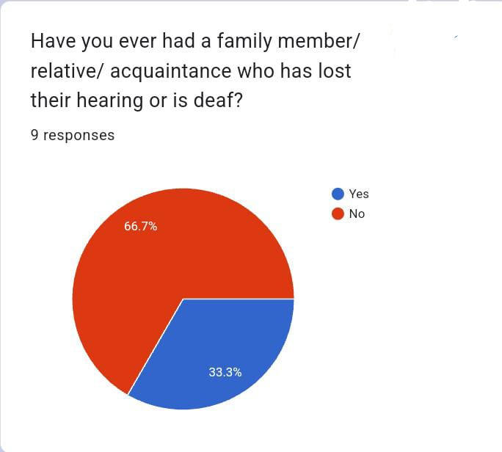

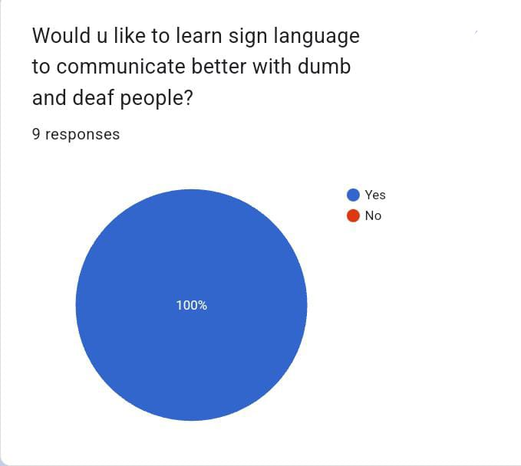

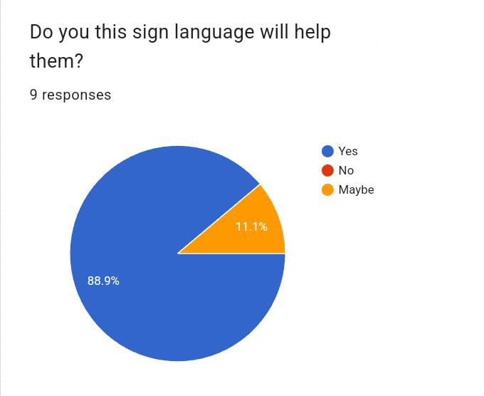

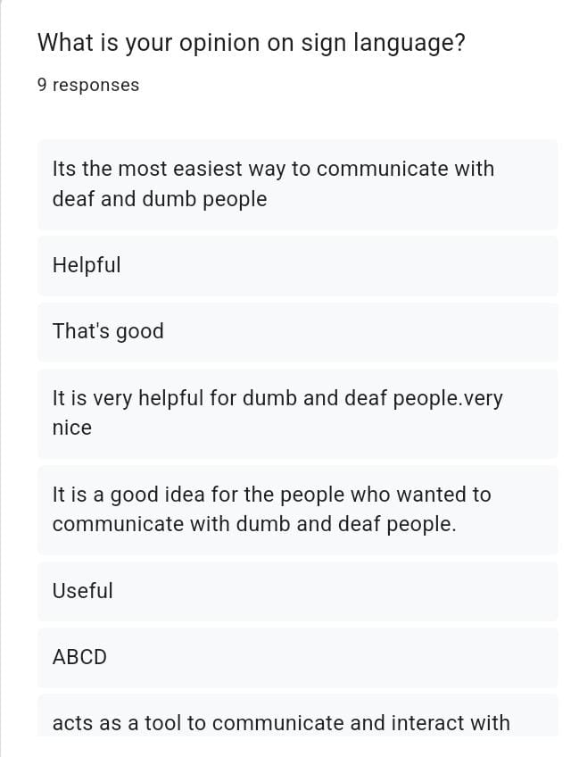

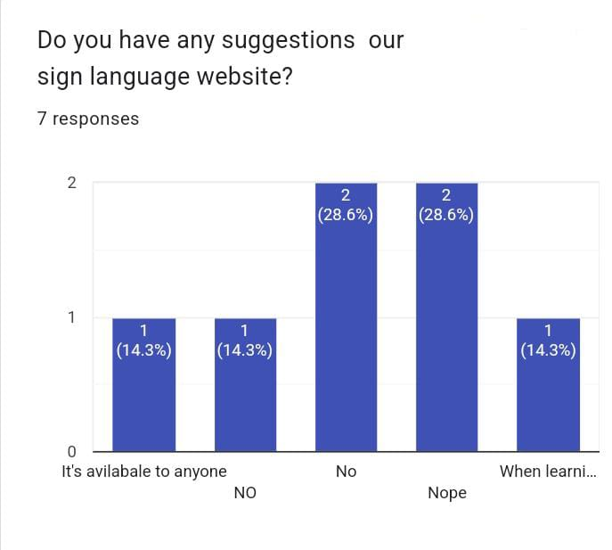

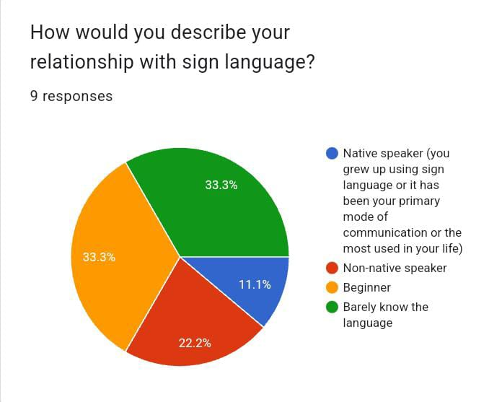

PROCESS MODEL

There are several process models that can be adapted for the development of our sign language.

Simplified outline of our website:-

❖ Requirements Gathering

❖ System Design

❖ Implementation

❖ Testing

❖ Deployment

❖ Operation and Maintenance

BUDGET

The estimated budget for this project according to our analysis is going to be Rs.150/- which will be spent for purchasing of the domain.Please note the above mentioned figures are subject to change and serve as a general guideline. The actual costs may vary based on specific requirements and market rates.

SYSTEM REQUIREMENTS AND ANALYSIS

Problem Definition:

Speech impaired people use hand signs and gestures to communicate. Normal people face difficulty in understanding their language. Hence there is a need of a system which recognizes the different signs, gestures and conveys the information to the normal people. It bridges the gap between physically challenged people and normal people.

Problem Analysis:

Our proposed system is sign language recognition system using convolution neural networks which recognizes various hand gestures by capturing video and converting it into frames. Then the hand pixels are segmented and the image it obtained and sent for comparison to the trained model. Thus our system is more robust in getting exact text labels of letters.

System Requirements

Hardware Requirements

Processor : Intel Core i5

Hard Disk : 250GB

RAM : 4 GB

Input Device : Webcam

Software Requirements

Operating systems : Windows 7, 10

Technologies : Python

Feasibility Study

The feasibility of the project is analyzed in this phase and business proposal is put forth with a very general plan for the project and some cost estimates. During system analysis the feasibility study of the proposed system is to be carried out. This is to ensure that the proposed system is not a burden to the company. For feasibility analysis, some understanding of the major requirements for the system are essential.

Three key considerations involved in the feasibility analysis are

1. Economical Feasibility

2. Technical Feasibility

3. Social Feasibility

Economical Feasibility

This study is carried out to check the economic impact that the system will have on the organization. The amount of funds that the company can pour into the research and development of the system is limited. The expenditures must be justified. Thus, the developed system as well within the budget and this was achieved because most of the technologies used are freely available. Only the customized products had to be purchased.

Technical Feasibility

This study is carried out to check the technical feasibility, that is, the technical requirements of the system. Any system developed must not have a high demand on the available technical resources. This will lead to high demands on the available technical resources. This will lead to high demands being placed on the client. The developed system must have a modest requirement, as only minimal or null changes are required for implementing this system

Social Feasibility

The aspect of study is to check the level of acceptance of the system by the user. This includes the process of training the user to use the system efficiently. The level of acceptance by the users solely depends on the methods that are employed to educate the user about the system and to make him familiar with it. His level of confidence must be raised so that he is also able to make some constructive criticism, which is welcomed, as he is the final user of the system

Output Media:

In this stage, it is carefully decided what(which) medium is most suitable for the user.

High quality videos

Tutorial videos

Social media content

Blog posts

Articles

Podcasts